Dear Caucus Goer, (HELP STOP VOTE FRAUD)
“Watch the Vote” needs your help to ensure an honest vote count in the Iowa Caucus, by helping to independently verify that the caucus results are reported accurately compared to the Iowa STATE Republican and Democratic Parties.
Real simple:
- Motion at the caucus to read the election results out-loud;
- Write down the announced results for all presidential candidates;
- Take a photo of the official caucus tally sheet with your phone (if it is not allowed, take a photo of your hand written sheet);
- Email the photo to: WatchTheVote2016@gmail.com
Of course, also email to your candidate’s election headquarters, if they have requested that, but also emailing it to Watch the Vote will help hold the campaigns and state parties accountable.
WHY DO THIS? Microsoft is tallying the results via a smartphone App. http://mashable.com/2016/01/07/microsoft-iowa-dems-gop-new-app-caucuses/#oZku3B8TE8qQ
The Iowa Republican and Democratic parties have embraced this. There has been around 200 training sessions for the use of turning your vote into electrons via phone App. Once your vote is turned into electrons, it is subject to easy computer manipulation. CNN reports that Democratic candidate Bernie Sanders' campaign has developed their own independent “in-house” smart-phone App to counter this. Bernie Sanders obviously doesn’t trust Microsoft to count his votes.
About “Watch the Vote”: We are a national organization for transparent elections. In 2012, we were instrumental in forcing the Iowa GOP to change the true state winner from Romney to Santorum. We need your help by performing the simple steps above. See the attached 2012 affidavit from Edward True, testifying that 20 votes were added for Mitt Romney AT THE STATE LEVEL. www.watchthevoteusa.com
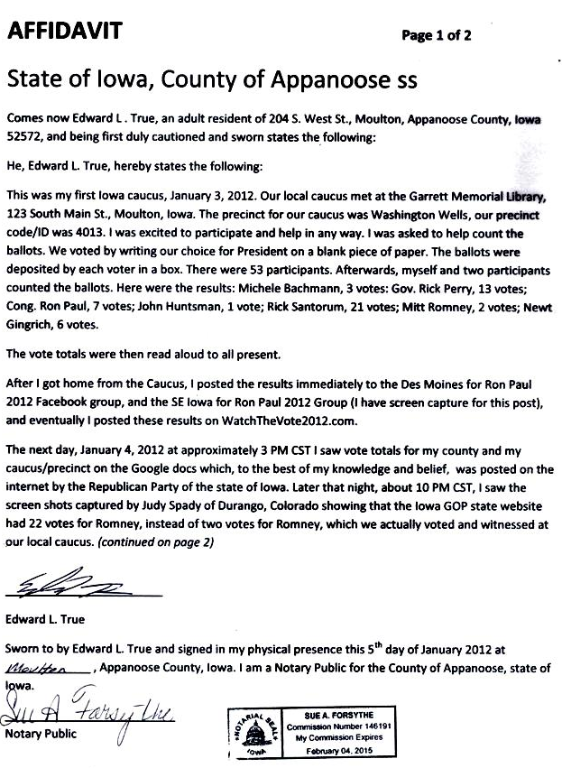

More at: http://www.watchthevote2012.com/AffidavitTrue.htm

